ILLUMINATION MEASUREMENT

Objective:
- Illumination measurement

Scope: All over the plant.

Ref: Nil

- Aspect: Nil
- Impact: Nil
- Hazards: Physical- Falling.

Responsibility: Company Electrician , Enginner

- Illumination measurement shall be done by using Lux meter in the horizontal plain at a level of 90 cms above the floor level. Lux is a unit of illumination of one square meter, which is one meter away from a uniform light source.

- Lux meter used for illumination measurement shall be calibrated.

- When taking measurements, verify that occupants and objects /materials are not blocking any light to the meter head. Measurement points that are shaded, even partially, by obstructions that are not moveable should be noted for potential elimination.

- Identify the measurement locations by marking. It is important to measure the same locations for the baseline and post-installation lighting systems, or the same representative type of locations if fixtures are relocated for the retrofit.

- For each different set of lighting conditions, locate at least 12 measurement points. Record lux level at 12 different points & then take average.

- Refer below table for minimum lux level limit required for different places. If lux level measured is below required limit, then additional light fixture needs to be installed.

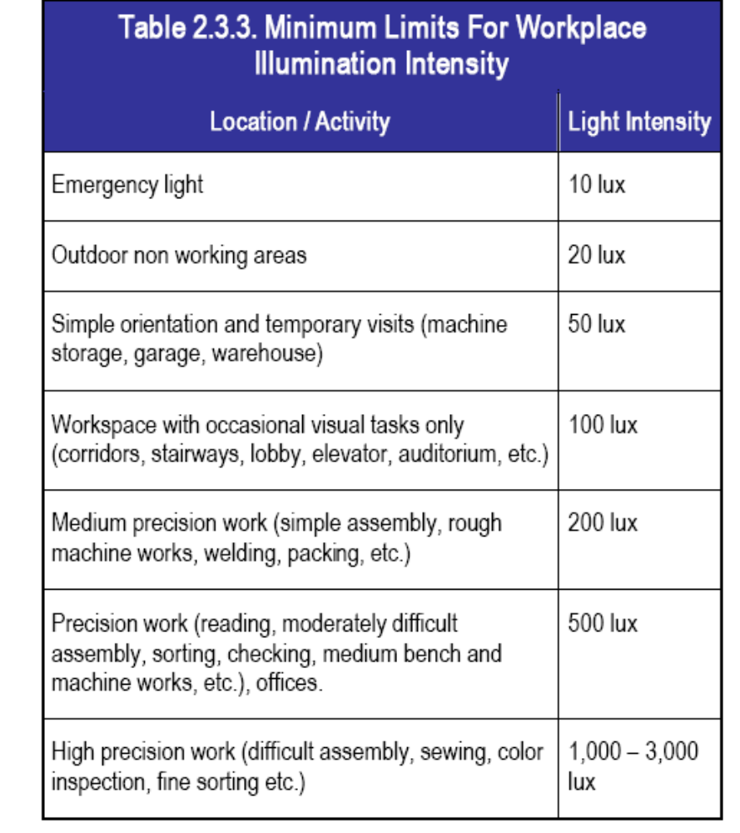

Prepared By:  Head – Electrical & Instrumentation PID1 | Reviewed & Issued By:  Management Representative | Approved By:  Head – Electrical & Instrumentation VAB
Signature: | Signature: | Signature:
Date:31.12.2021 | Date: 31.12.2021 | Date : 31.12.2021

